**To Check string having Digit or not**

**isdigit() : whether given string completely digits or not**

**Check for 3 Digits**

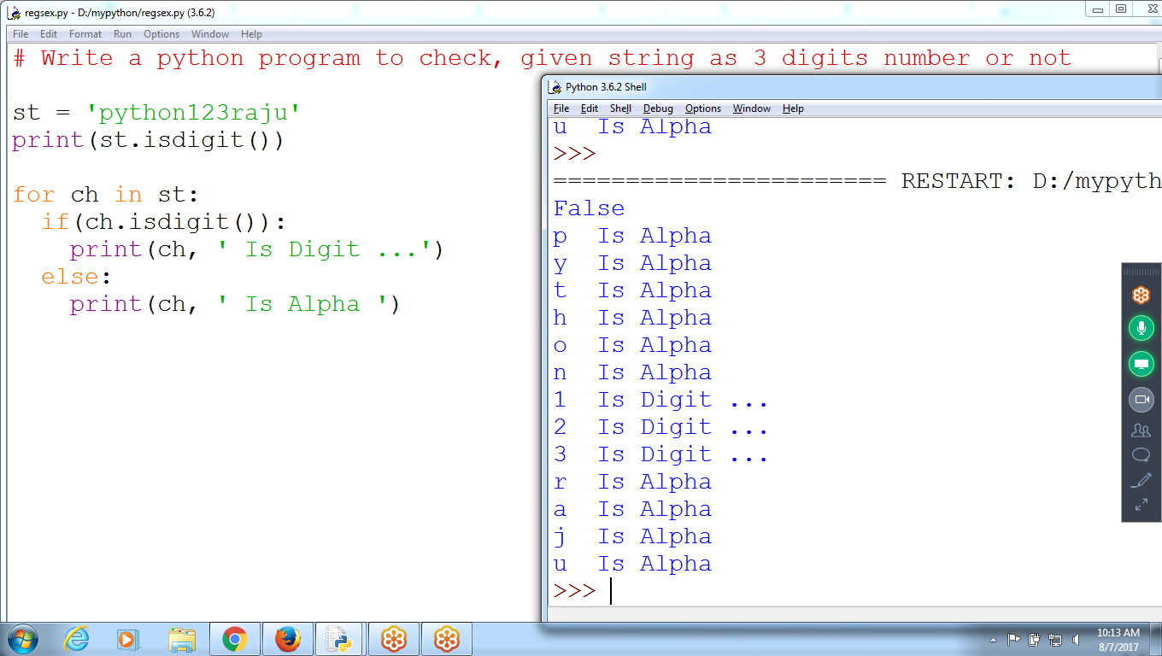

**To Check 3 digits number existing or not in STRING**

**# Write a python program to check, given string as 3 digits number or not**

st = 'python67raju*29-87sivaji8927anand kishre12 kiran76'

n=0

dst = ''

for ch in st:

if(**ch.isdigit()**):

print(ch, ' is digit ')

n = n+1

dst = dst+ch

if(n ==3):

print(' 3 Digits number found ',dst)

break

else:

n=0

dst = ''

print(ch, ' is Alpha ')

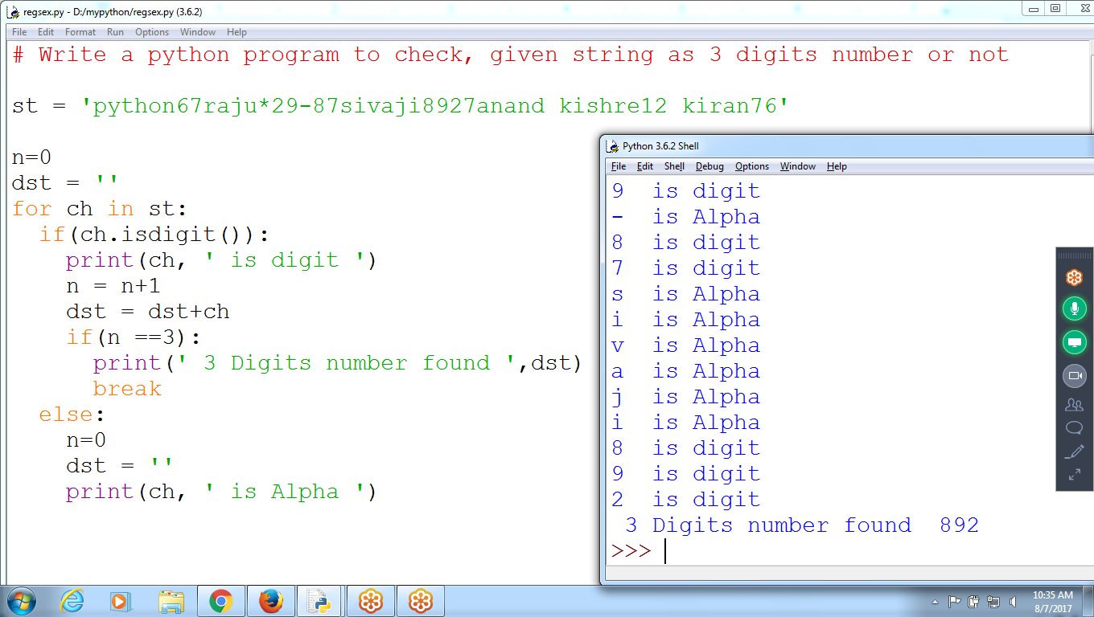

**Print list of 3 digits number sets**

st = 'python67raju*29-87sivaji8927anand kishre456 kiran768 anand'

n=0

dst = ''

**ls = []**

for ch in st:

if(ch.isdigit()):

n = n+1

dst = dst+ch

if(n ==3):

print(' 3 Digits number found ',dst)

ls.append(dst)

n=0

dst = ''

else:

n=0

dst = ''

print(' 3 Digits sets are ', ls)

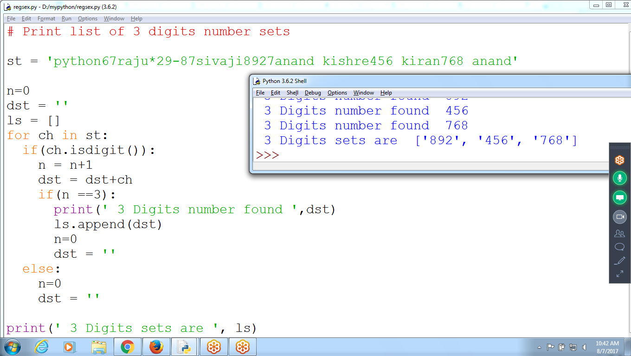

**List of 5 digits set**

Change if statement (if n == 5)

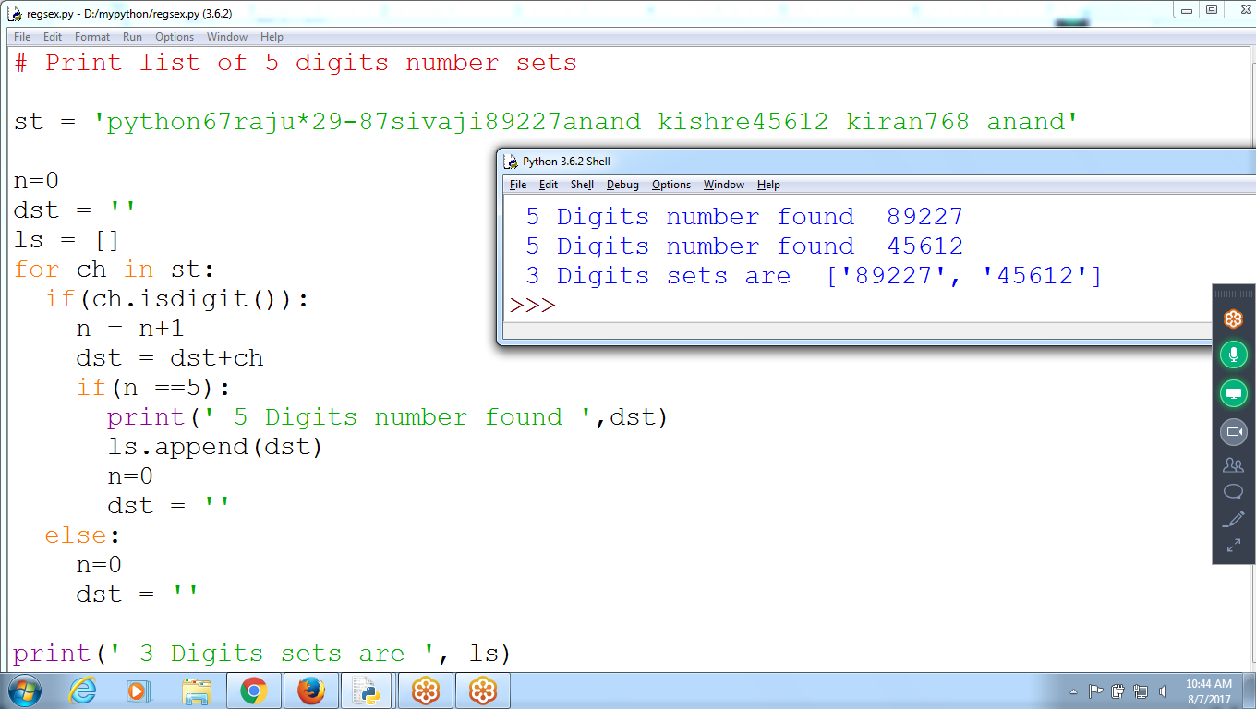

**Using Functions find 5 digit number**

**Passing String to Function**

# Print list of 5 digits number sets

def f1(st):

n=0

dst = ''

ls = []

for ch in st:

if(ch.isdigit()):

n = n+1

dst = dst+ch

if(n ==5):

print(' 5 Digits number found ',dst)

ls.append(dst)

n=0

dst = ''

else:

n=0

dst = ''

**return ls**

st = input('Enter ANy string ')

print(' list of 5 Digits are ', **f1(st))**

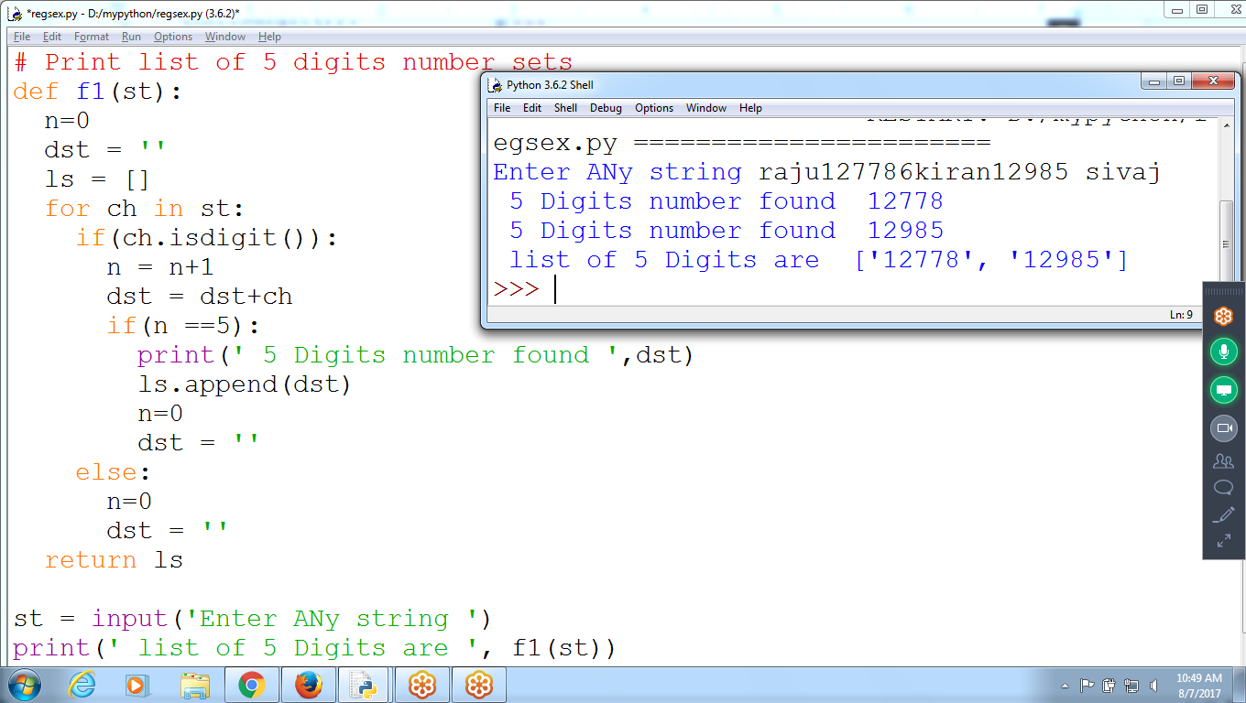

**Python Pattern Matching using LIBRARY “re”**

1. **Pattern Matching 1: 3 Digits ::: Using \d**

# find 3 digits number exist in String

import re

st = 'raju12 kiran456 jeevan12 986 sunil'

**reobj = re.compile('\d\d\d')**

**print(reobj.search(st))**

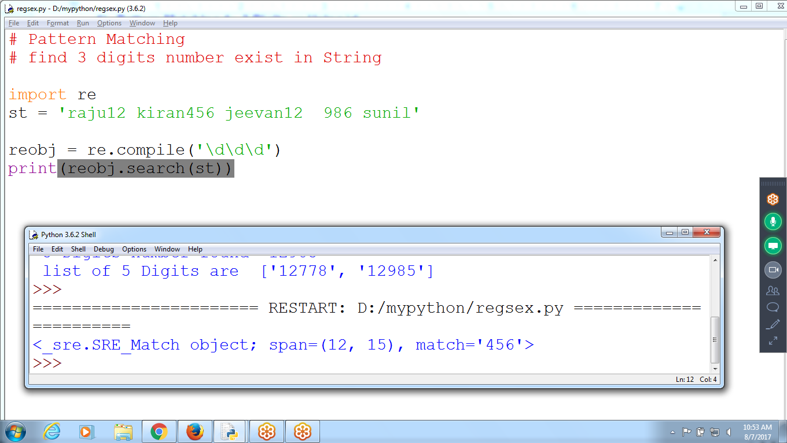

**#IF not Existing returns NONE**

import re

st = 'raju12 kiran45 jeevan12 98sunil'

reobj = re.compile('\d\d\d')

print(reobj.search(st))

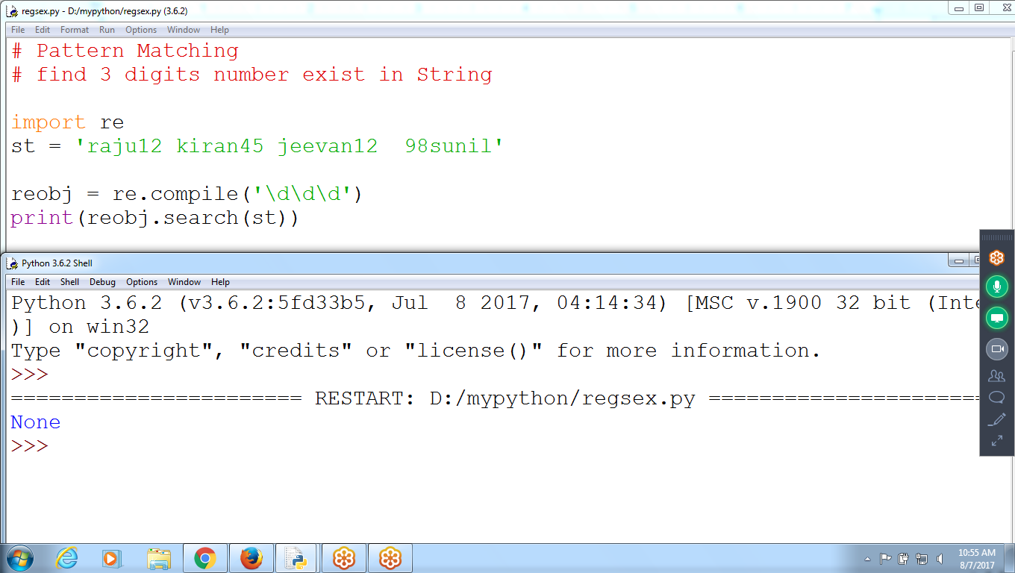

compile() : To get Regular Expression object

search() : Returns FIRST Found in a given string

**# SEarch returns FIRST Found**

**import re**

**st = 'raju12 kiran456785 jeevan12 98sunil'**

**reobj = re.compile('\d\d\d')**

**print(reobj.search(st))**

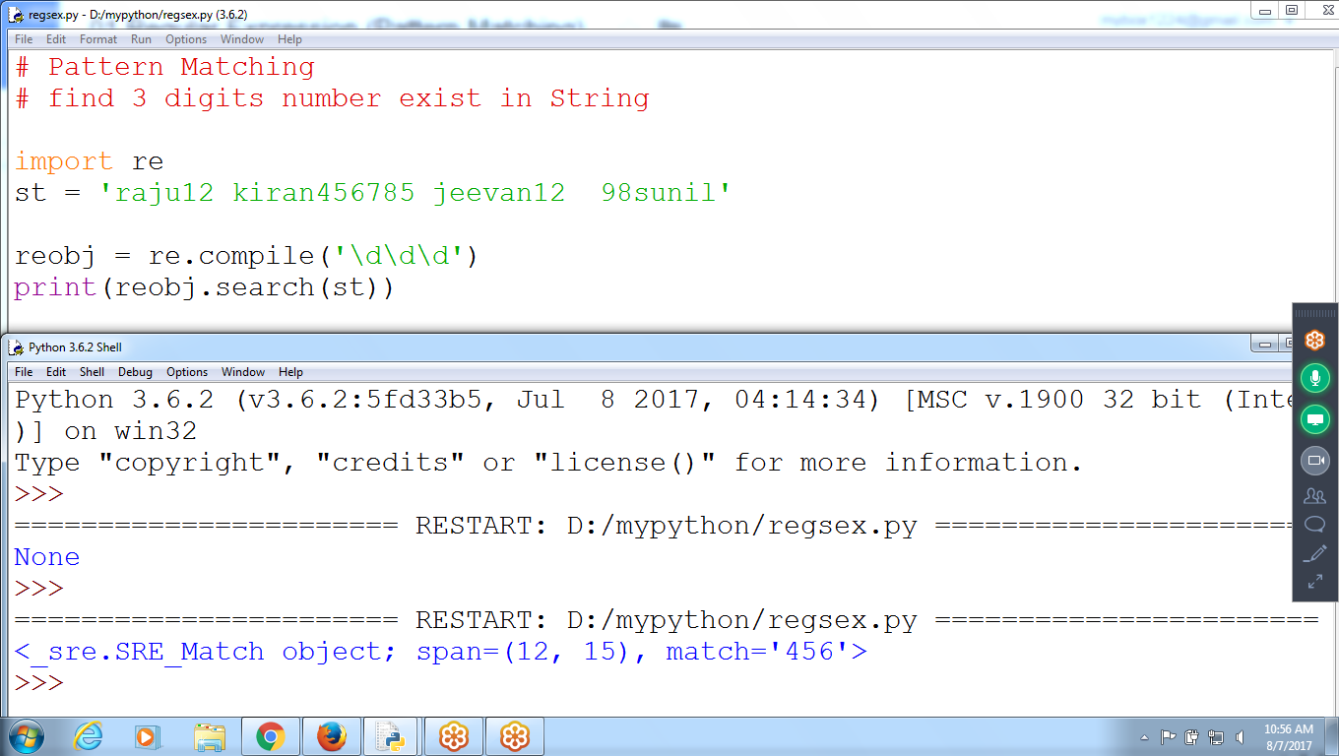

searchall() : returns all sets

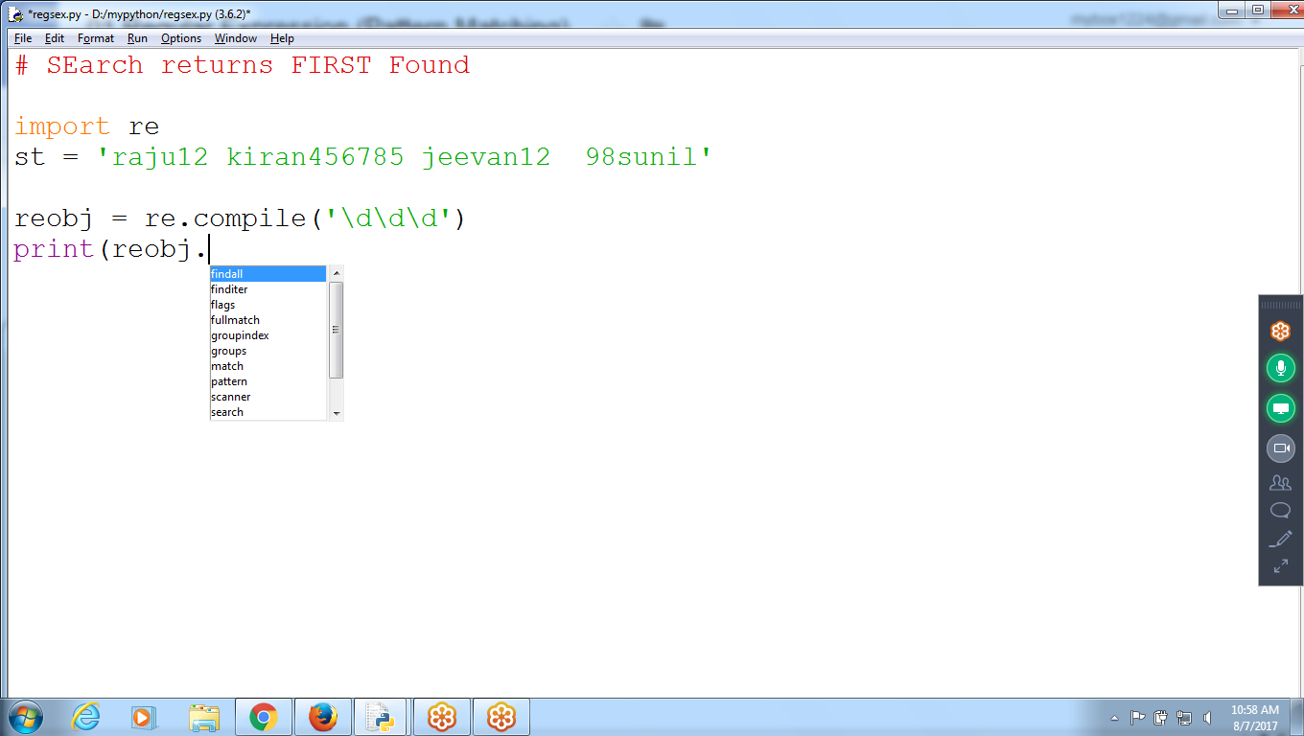

**FIND All Objects**

**Search() : returns first Found**

**findall(): Returns all sets**

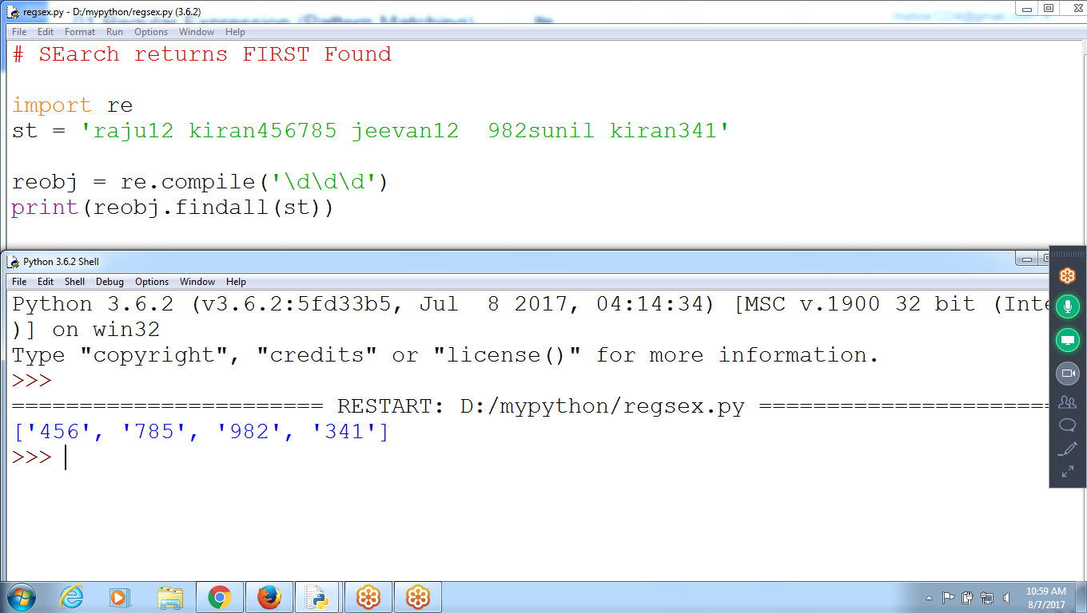

**# SEarch returns FIRST Found**

**# Findall Returns all Searches**

import re

st = 'raju12 kiran456785 jeevan12 982sunil kiran341'

reobj = re.compile('\d\d\d')

res = reobj.findall(st)

if(res == None):

print(' 3 Digits number not Found ')

else:

print(' 3 Digtis Numbers are ',res)

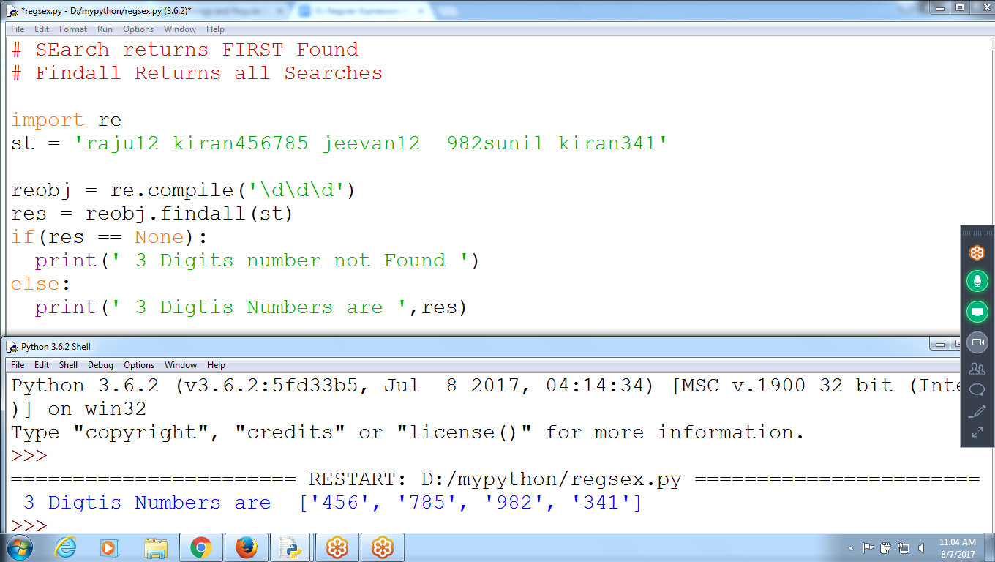

**Compile() : Method Regular Expression Object pattern ‘\d\d\d’**

**search() : search for given string**

**group() : Return First Result of the pattern**

**Checking for 5 Digits**

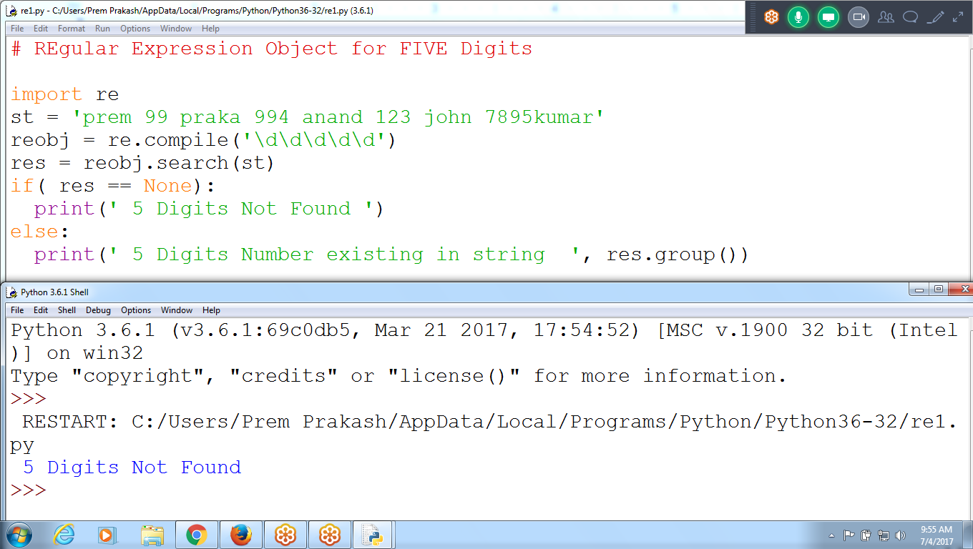

# REgular Expression Object for FIVE Digits

import re

st = 'prem 99 praka 994 anand 123 john 7895kumar'

reobj = re.compile**('\d\d\d\d\d')**

res = reobj.search(st)

if( res == None):

print(' 5 Digits Not Found ')

else:

print(' 5 Digits Number existing in string ', res.group())

**FIND Number of type 999-999-999**

# Find number of type 999-999-999

import re

st = 'raju12 kiran456-785-123 jeevan123-678 982-232-111sunil kiran341'

reobj = re.compile('\d\d\d-\d\d\d-\d\d\d')

print(reobj.findall(st))

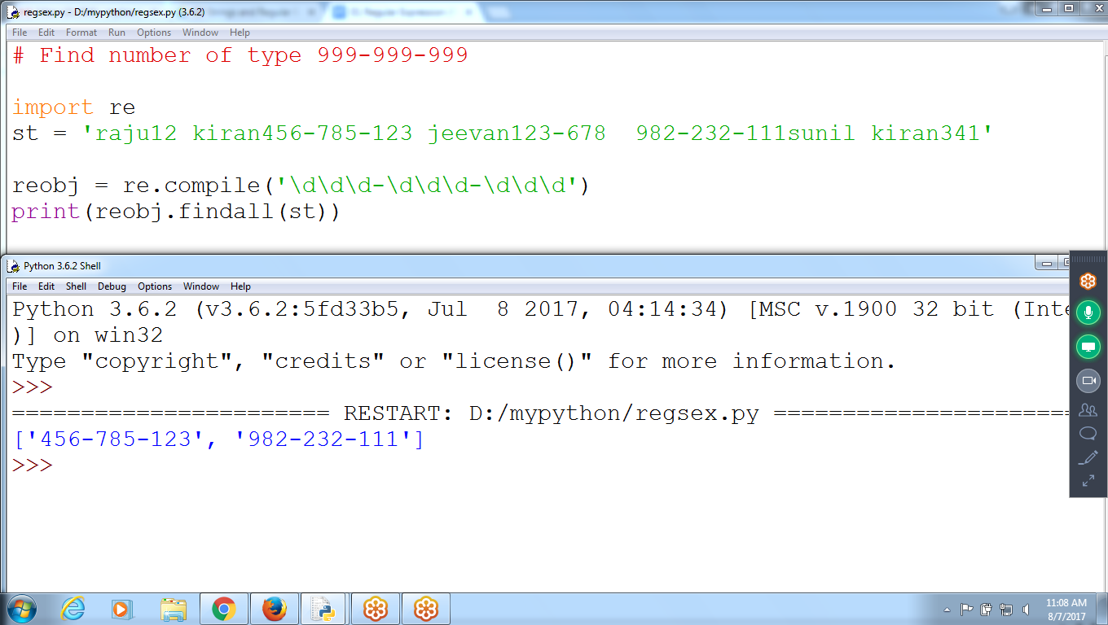

**# Find Groups**

**import re**

**st = 'raju12 kiran456-785-123 jeevan123-678 982-232-111sunil kiran341'**

**reobj = re.compile('(\d\d\d)-(\d\d\d-\d\d\d)')**

**res = reobj.search(st)**

**print('First Group 3 Digits= ', res.group(1))**

**print('Second Group 6 Digits = ', res.group(2))**

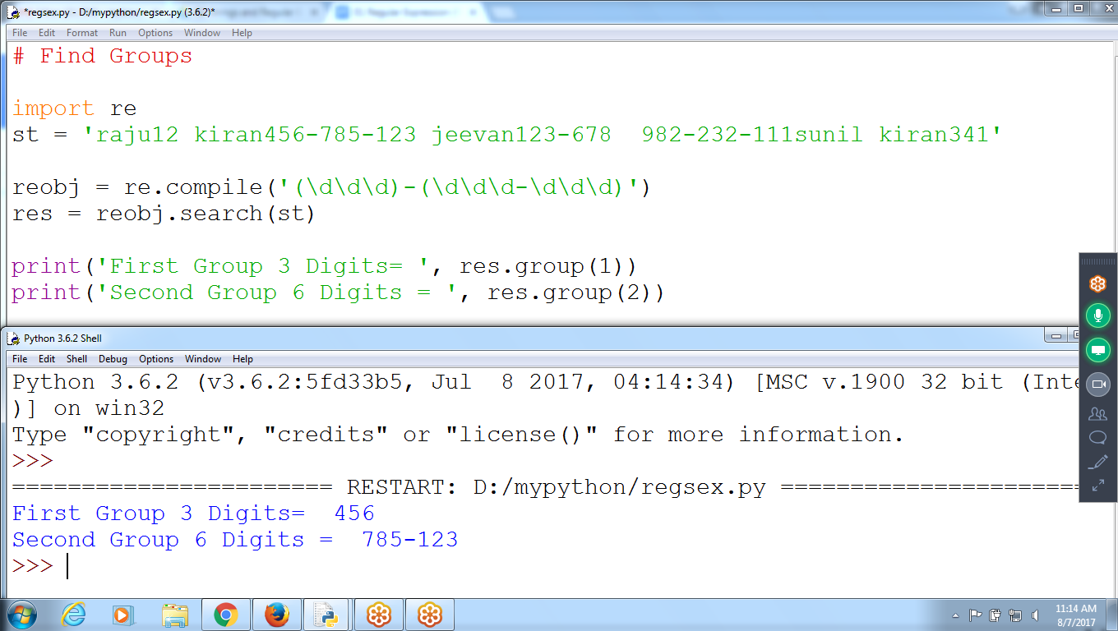

**Difference between “Search” and “findall”**

**import re**

**st = 'prem 121-678-789 Prakash 994 karthik 994-768-999 raju 988-678-123 siva'**

**reobj = re.compile('\d\d\d-\d\d\d-\d\d\d')**

**res = reobj.search(st)**

**print(res)**

**res2 = reobj.findall(st)**

**print(res2)**

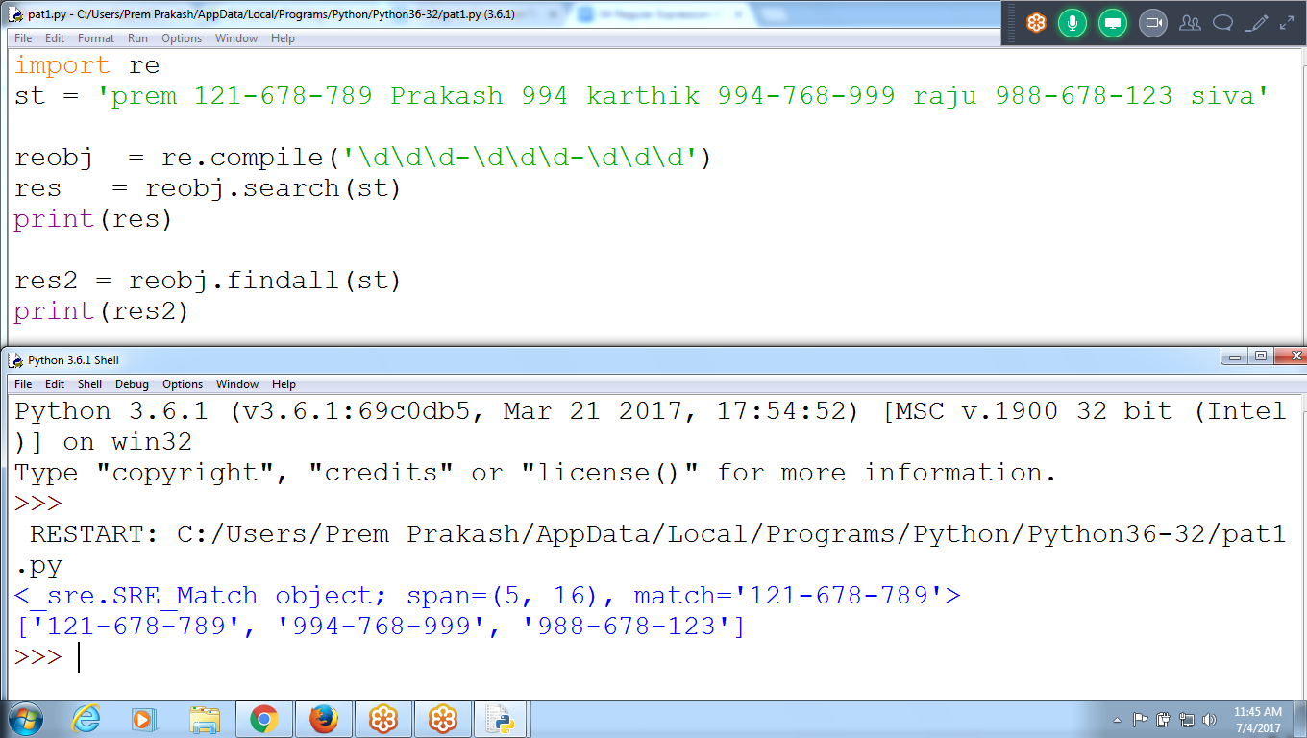

**# Find Number with ( and space**

import re

st = 'prem (234) 897-123kash 994 karthik 040 123-456 raju (001) 678-123 siva'

reobj = re.compile('\(\d\d\d\) \d\d\d-\d\d\d')

print(reobj.findall(st))

